Adora
Montminy
F a s h i o n D e s i g n

Pro Skills
Drawing Sketch

Contact

Phone
+123-456-7890

Email
hello@reallygreatsite.com

Website
www.reallygreatsite.com

Address
123 Anywhere St.,Any City, ST 12345

About Me

I am a fashion designer with more than 3 years of experience. I design various clothes and show them off at fashion events.

Reference
Trend Forecasting Fashion I l lustration
Digital Fashion Drawing

Education

2010 - 2012
School of Larana
Bachelor Of Design
2015 - 2018
University of Keithston.
Master Of Design

Experience

Really Great Company | 2016-2018 Product Fashion Designer
There are many variations of passages of Lore Ipsum
available, but the majority.
Majority hav suffered alteration in some form.

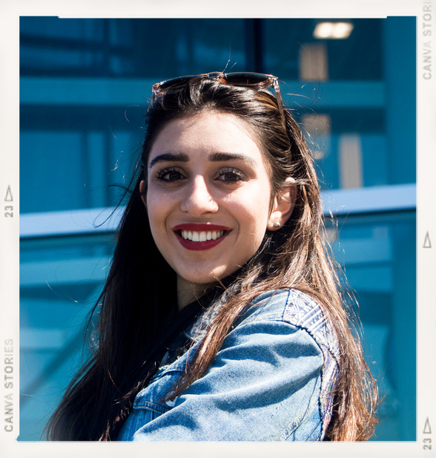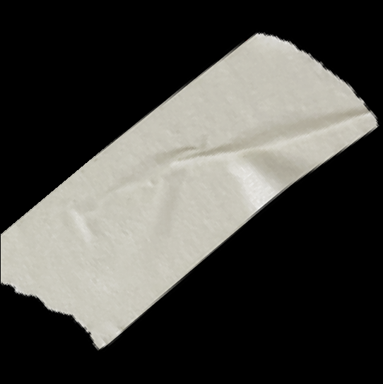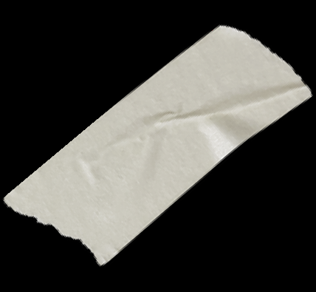Juliana Silva Wardiere Inc. / CEO 123-456-7890
Reese Miller Wardiere Inc. / CEO 123-456-7890

Really Great Company | 2016-2018 Product Fashion Designer
There are many variations of passages of Lore Ipsum
available, but the majority.
Majority hav suffered alteration in some form.

